THE GAMBIA CONSUMER PRICE INDEX (CPI) MARCH 2021


REPUBLIC OF THE GAMBIA

Important announcement

With the publication of the January 2020 index, GBOS has updated the official CPI series. This involves updating the weights and product basket as well as a number of methodological improvements. These updates improve the transparency, relevance and representativity of the CPI. For the first time, GBoS will also be calculating CPI indexes for urban and rural areas. These estimates are available on our website. See www.gbosdata.org/downloads, www.gambia.opendataforafrica.org/nsdp or the Annex to this release for full details.

To highlight these improvements, the long run CPI index has been re-referenced (rescaled) to January 2020=100. Please note that historical inflation rates are unaffected by this rescaling.

Please visit our website for the full CPI series.

From March 2020 to March 2021, the year on year All-items Consumer Price Index (CPI) inflation rate increased by 7.40 percent. Food and Non-Alcoholic Beverages increased by 7.95 percent whilst Non-Food Products rose by 4.08 percent.

In March 2021, the All-items CPI index was 108.71 an increase of 1.16 percent over the February 2020 All-items index of 107.46.

From March 2020 to March 2021, within Food and Non-Alcoholic Beverages, ‘Oils and Fats’ increased by 21.34 percent, ‘Fruits and Nuts’ increased by 12.82 percent, ‘Fish’ increased by 23.17 percent, ‘Meat’ increased by 10.08 percent, ‘Bread and Cereals’ increase by 3.86, and ‘Milk, Cheese and Eggs increased by 3.63 percent.

Over the same period, for the Non-Food products, major increases were recorded by ‘Education’,85.35 percent, ‘Miscellaneous’, 9.97 percent, ‘Transport’ 4.95 percent, ‘Alcoholic Beverages, Tobacco and Narcotics’, 11.08 percent, ‘Hotels, Cafes and Restaurant’, 7.46 percent, ‘Furnishing, Household Equipment, etc.’, 5.11 percent, and ‘Housing, Water, Electricity, Gas and other Fuels’, 3.37 percent.

From February 2021 to March 2021, the highest inflation rates were recorded for, ‘Oils & Fats’ 9.48 percent, ‘Bread and Cereals’ 4.05 percent, ‘sugar Jam, honey & sweets ‘Fruits and Nuts’ 3.10 percent, ‘Milk, Cheese & Eggs’, 1.80 percent, ‘Non Alcoholic Beverages’, 1.05 percent and ‘Fish’, 0.68 percent.

Using the 12 months-moving-average measure, the annual inflation rate was 8.0 percent in March 2021 compared to 6.1 percent recorded in February 2021.

All-items year on year Inflation Rate (Comparison with the same month for the previous year)

Year | Jan | Feb | March | April | May | Jun | July | Aug | Sept | Oct | Nov | Dec
2019 | 6.08 | 6.16 | 6.13 | 6.91 | 7.46 | 7.35 | 7.31 | 7.36 | 7.58 | 7.55 | 7.73 | 7.68
2020 | 7.36 | 7.84 | 7.58 | 5.61 | 5.40 | 5.13 | 4.82 | 5.43 | 5.18 | 5.58 | 5.77 | 5.67
2021 | 7.57 | 6.38 | 7.4

Figure 1: Annual changes – Comparison with the same month of the previous year (March 2020 – March 2021)

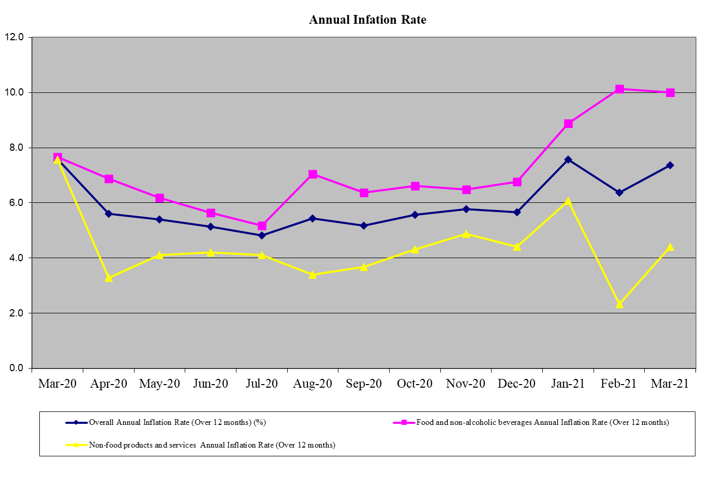

Figure 2: Monthly changes - Comparison with the previous month: February 2021 to March 2021

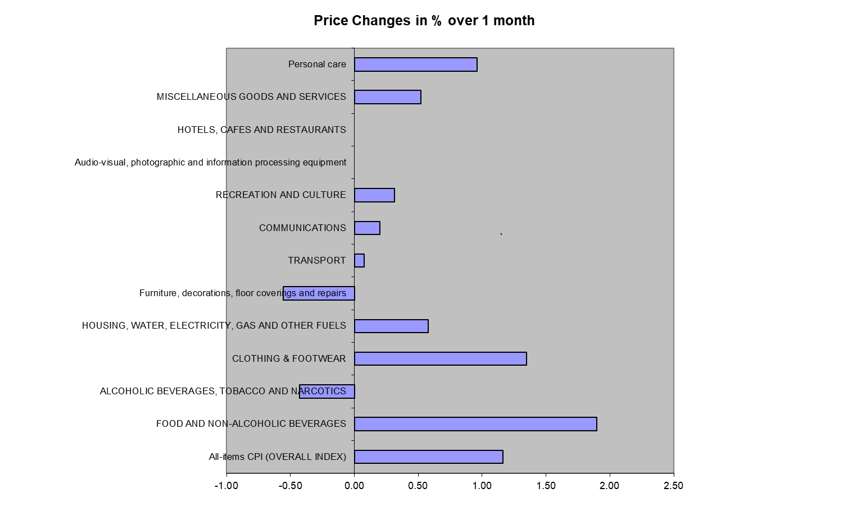

CONTACTS
Gambia Bureau of Statistics (GBOS)
Kanifing Institutional Layout
P.O.Box 3504 Serekunda
Tel. (220) 4394529
Tel. (220) 7913788
Website: www.gbosdata.org/downloads
email: darboefatou85@gmail.com
email: mawdogibba88@gmail.com

